**Help Documentation**

The FluBarDB is a database for storing and analyzing IVs’ barcode segments, accessible directly via http://virusbarcodedatabase.top/database/index.html. The FluBarDB database includes six core modules: Home, Barcode, Genetics Analysis, Toolkit, Literature, and Contact Us. Users can easily navigate between these modules by clicking on their respective names in the top navigation bar on the homepage. The following is the basic introduction of each module:

1. **Home**

1. Navigation Bar: Located at the top, it provides quick access to the six modules, enhancing user navigation efficiency.
2. FluBarDB Database Overview: The central area briefly introduces the database's functions, uses, and technical advantages.
3. Common Functionality Buttons: Provides buttons for various common functions, allowing users to quickly access specific operation pages.
4. Laboratory Address and Contact Information: The bottom of the page includes detailed contact information for the laboratory, including address and contact details.

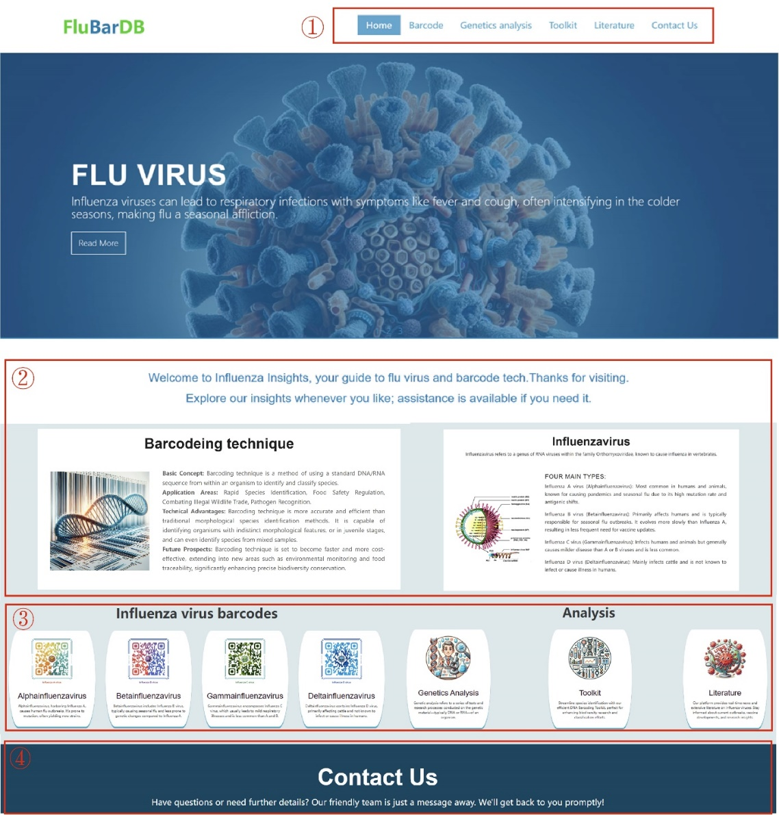

2. **Barcode**

The Barcode module is mainly used to present the basic information of IVs and provide the relevant barcode segments.

1. Introduction: Overview of IVs’ evolution, genomic structure, and global distribution.
2. RNA Barcoding: Displays barcode segments and primers for accurate IV strain identification.
3. One & Two Dimension: Provides visual data for IVs’ 1D and 2D codes.
4. Download: Allows downloading of barcode segment information and barcode images for research use.

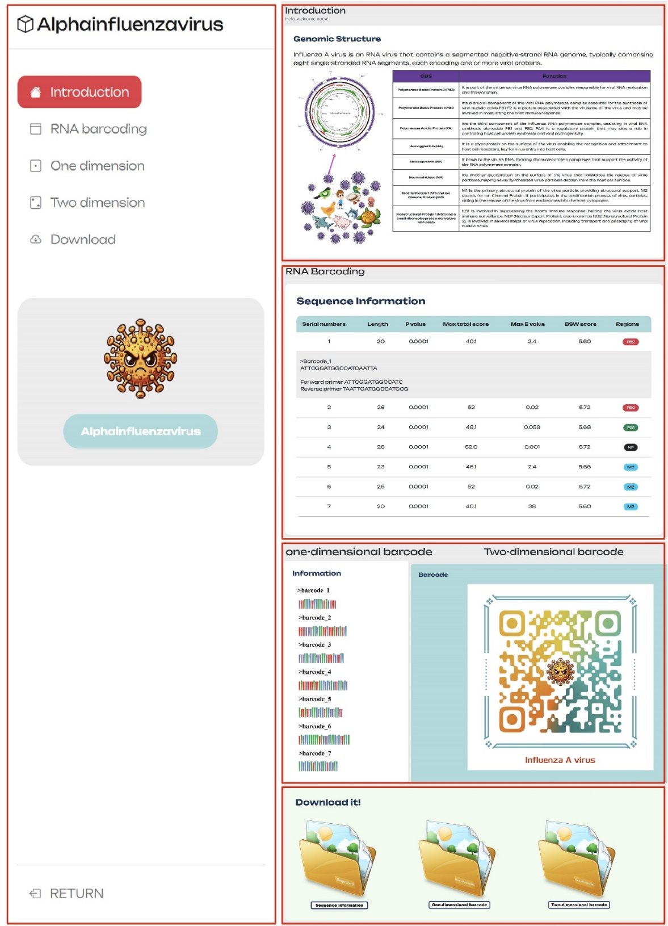

3. **Genetics analysis**

This module presents the genetic analysis results of virus populations within the class Insthoviricetes in tabular form, covering multiple dimensions of data, including:

1. Basic Data Description: Analysis of nucleotide sequences and assessment of variation sites to identify genetic traits and understand genetic diversity.
2. Sequence Alignment: Displays the genetic differences between various species, revealing the genetic relationships within and between species.
3. Population Genetic Analysis: Evaluation of polymorphism to reveal evolutionary trends and genetic exchange.

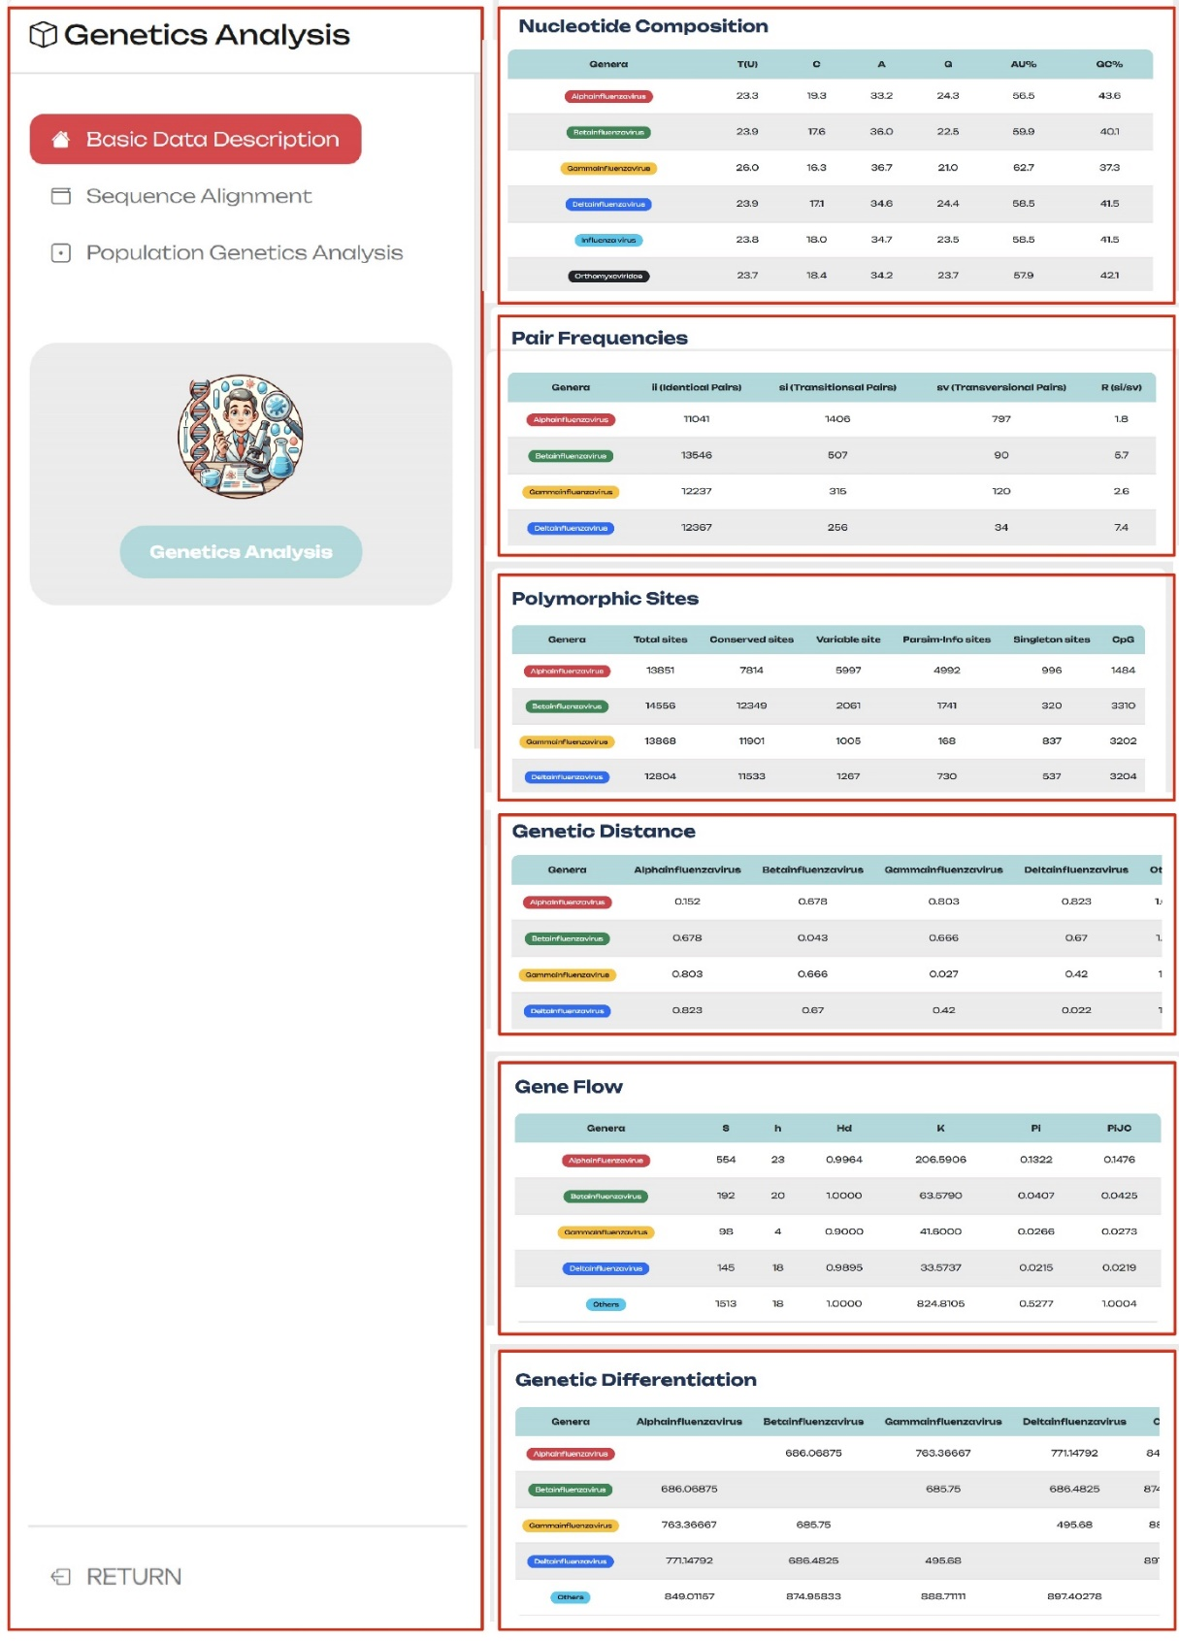

4. **Toolkit**

The Toolkit module provides a full range of services from sequence processing to barcode segment data visualization.

1. FASTA Sequence Processor: This tool is designed for processing biological sequence data, particularly DNA sequences. It automates the removal of low-quality or erroneous bases using regular expressions and string processing techniques to ensure accuracy in subsequent analyses. Additionally, it quickly calculates DNA sequence length and GC content, which are important for studying genomic stability and gene expression. The processed data can be exported in FASTA or CSV formats for further analysis and research.
2. Blast: This core component of the Toolkit module enhances sequence alignment efficiency. Users can upload target sequences and align them with a predefined IVs barcode segment library. The alignment’s “Percent Identity” threshold can be adjusted according to experimental needs to optimize the results.
3. Batch data analysis: This integrated Python package offers functionality for barcode segment testing, improving code reusability and maintainability while simplifying the process. Users can calculate the recall rate and specificity of barcode segments according to specific operational steps.
4. Data visualization Tool: The design goal of this tool is to convert complex sequence information into intuitive visual charts, aiding researchers in better data comprehension. It automatically generates corresponding 1D and 2D barcodes based on input sequence information, facilitating quick identification and analysis.

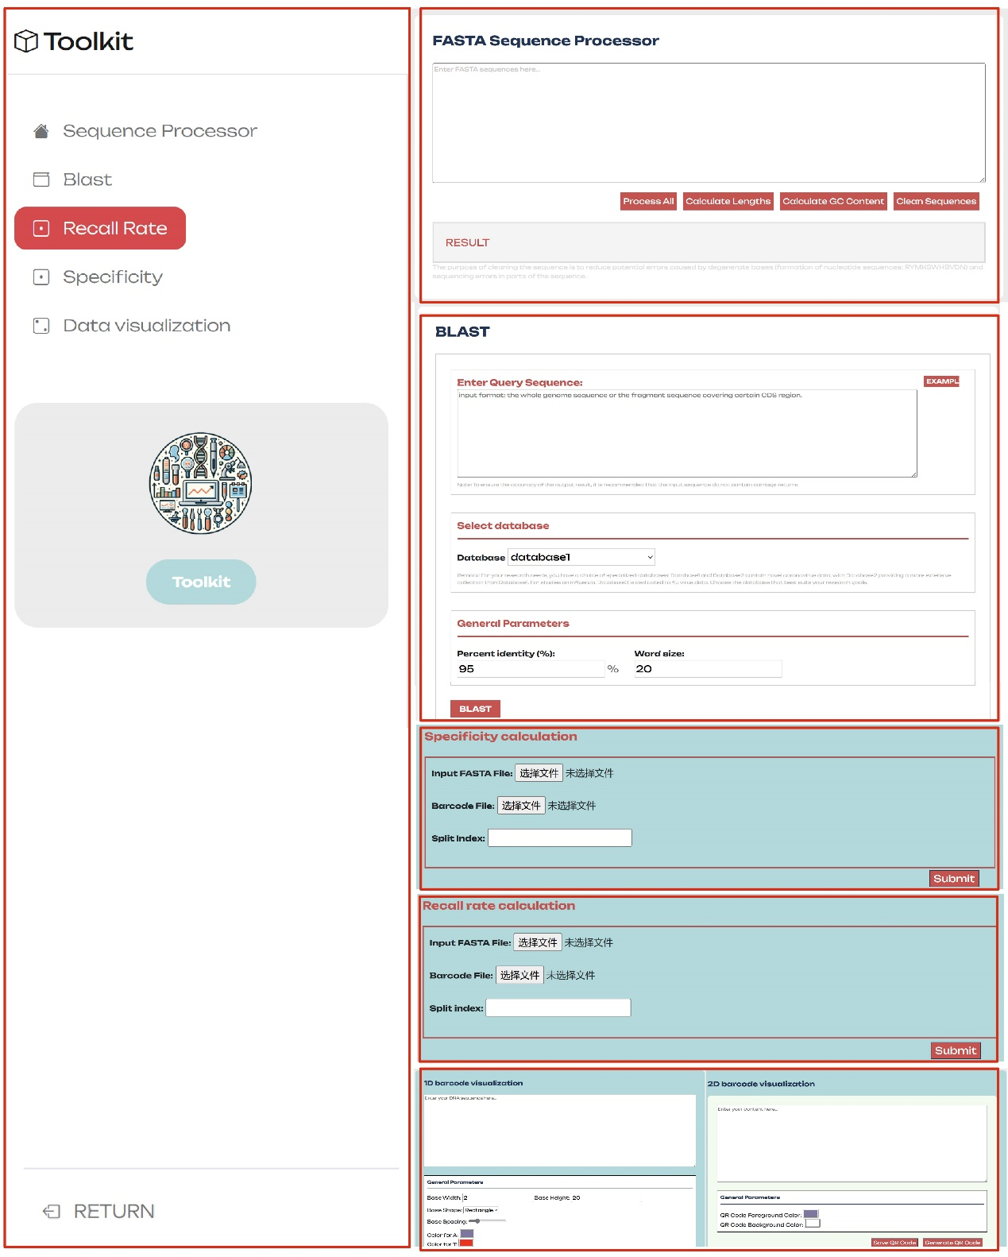

5. **Literature**

This module integrates scientific literature and news reports related to IVs, providing users with a convenient and timely information retrieval channel.

1. Literature: Aggregates articles from authoritative journals on IVs, including basic research, clinical trials, and vaccine development.
2. News: Provides real-time news from public health organizations, research institutions, and media on IVs outbreaks, transmission, preventive measures, and public health policies.

